Terms of Reference – Boiler Plate Headings
When creating a terms of reference for any working group, the following headings may be included as required.
- Cover Page and content table are optional
- Version Control
- Title of Group
- Background
- Reporting Structure/Organogram (outline the hierarchy of the group within the governance structure of the project – that is, who does it report to and who reports to it)
- Terms of Reference
  - Outline the purpose/responsibility for the group
  - Members of the group (including role i.e. chair, deputy, secretary etc)
  - Observers of the group
  - Meeting logistics (in person, on line)
  - Quorum (Minimum number of people required to allow a meeting to go ahead)
  - Voting
  - Meeting Frequency
  - Meeting records & document management
  - Confidentiality

On the next page you will find a generic template that may be used to help create terms of reference for a working group.

[LOGO]

[Scientific Advisory Board]: Terms of Reference

Version Control
Please note that this document is uncontrolled if printed. For the latest version please contact [the [Programme/Project/Other] Manager or visit the governance section of the [insert name] website (insert link)].
Date/Version | Changes Implemented | Changes Made By | Changes Approved By

Overview
The [Scientific] Advisory Board (Board) will provide independent oversight of the [Insert Programme/Project name]. They will advise on the strategy adopted, the progress of the [programme/network/[Programme/Project/Other]] in addition to [reviewing and monitoring the risk management plan]. The (Board)is as an advisory body convened to support and strengthen the work of the [Programme/Project/Other] which interacts with the [insert name ie Strategic Management Group].

Chair
The (Board) has an independent chair [insert name & position].

Board Members
[Insert names and positions of all delegated members of the Board]
Reporting Structure
The Board provides guidance to the SMG as shown below. The point of contact for the Chair is the PI/ the [Programme/Project/Other] Manager, however, any member of the [Programme/Project/Other] may consult with the Board by tabling agenda items at scheduled meetings.
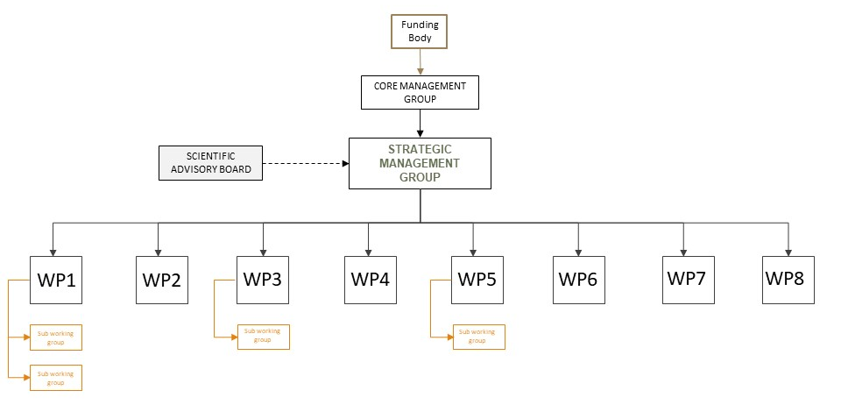

Role and responsibilities
Whilst the [insert name of overall governing group], comprised of the [Principal Investigator and co-investigators of the [Programme/Project/Other]], are accountable for the [Programme/Project/Other] progressing and attaining its objectives successfully, the remit of the (Board) is to provide independent oversight of the [Programme/Project/Other].
The [Board] will do this via the provision of advice on the [research/governance/other] strategy adopted, the progress of the [programme] in addition to [reviewing and monitoring the risk management plan].
At each meeting the [Board] will:
- Receive and comment on a progress update from the PI (and/ or others).
- Ensure views from key stakeholders are considered in the [Programme/Project/Other]’s design and ongoing implementation of the project.
- Monitor and advise on the strategy being undertaken in the [Programme/Project/Other]:
  - Review progress towards relevant milestones
  - Support and advise on the research being conducted, and capacity development approach and activities,
  - Provide advice on publications and other outputs,
  - Support the [Programme/Project/Other] in its activities aimed at generating impact, including the development of a communication plan and dissemination activities.
  - Provide advice and independent oversight of the [Programme/Project/Other]s approach to risk management, including review and final approval of the risk management plan.
- Advise on current and future policy developments that relate to the [Programme/Project/Other]’s work.
- Advise on future research priorities and identify opportunities for new areas of research or funding that might support the aims of the [Programme/Project/Other].
- To act as ambassadors for the [Programme/Project/Other], highlighting its activities and any relevant achievements to other key stakeholders.

Meeting frequency and structure
- The [Board] will meet [insert frequency].
- Meetings will be conducted [in person/by video/teleconference/other].
- [A provisional agenda will be drawn up by the Chair in consultation with the PI and [Programme/Project/Other] Manager and circulated at least four weeks in advance of the meeting.
- The final agenda and any papers will be circulated at least a week in advance of each meeting.
- Meetings will not be open to the public.
- The [Programme/Project/Other] Manager is responsible for the provision of administrative support meetings of the Board.

Meeting Records & Document Management
The business conducted at the [Scientific Advisory Board] meetings and actions required will be [recorded and subsequently signed off by the Chair. The agenda will be circulated to Board members and others in attendance at least two weeks prior to each meeting and the minutes available two weeks after].
The Terms of Reference for the [Board will be/will not be] made publicly available on [the [Programme/Project/Other]’s website].

Remuneration [Optional]
The role of an Board member is unpaid, however, the [Programme/Project/Other] will reimburse members for all reasonable costs incurred whilst fulfilling their roles on the board and which cannot be recovered from their own organisation].
The costs incurred by [Board] members shall be reimbursed as follows [insert details of any limitations and the procedure to book travel/reclaim costs etc].

Confidentiality [Optional]
Any information shared within the [Board] marked as confidential must remain so. Members must not disclose the contents of any discussions, presentations or documents (whether verbally in written format (including digital or hand written).

