Terms of Reference – Boiler Plate Headings
When creating a terms of reference for any working group, the following headings may be included as required.
- Cover Page and content table are optional
- Version Control
- Title of Group
- Background
- Reporting Structure/Organogram (outline the hierarchy of the group within the governance structure of the project – that is, who does it report to and who reports to it)
- Terms of Reference
  - Outline the purpose/responsibility for the group
  - Members of the group (including role i.e. chair, deputy, secretary etc)
  - Observers of the group
  - Meeting logistics (in person, on line)
  - Quorum (Minimum number of people required to allow a meeting to go ahead)
  - Voting
  - Meeting Frequency
  - Meeting records & document management
  - Confidentiality

On the next page you will find a generic template that may be used to help create terms of reference for a working group.

[LOGO]

Version Control
Please note that this document is uncontrolled if printed. For the latest version please contact [insert name] or visit ([insert weblink]).
Date/Version | Changes Implemented | Changes Made By | Changes Approved By

[Insert Name] Group: Terms of Reference

Background & Purpose
Insert a short summary of the objectives for that this working group exists and its primary functions.
The [insert name] working group is responsible for…..[insert text].

Reporting Structure
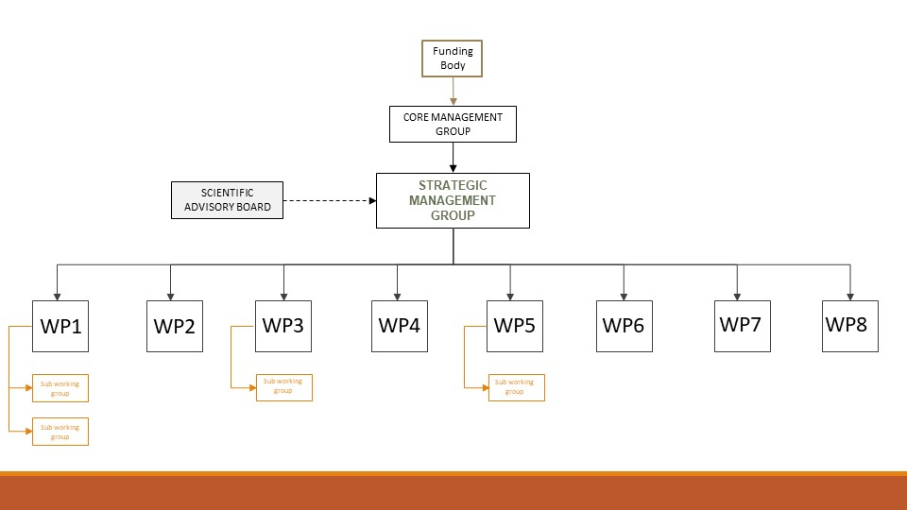

Terms of Reference
The designated responsibilities of the [insert name] working group are as follows:
- List the primary responsibility
- List the secondary responsibility
- And so on

Membership
List all members of the group
Chair: Professor I. Lead

Members: Dr I. Dea
Mr S. Mith
Dr S. Tudy

Observers: Dr W. Atcher

If it is not be possible for members named above to attend a meeting, they may nominate an alternate to attend a meeting in their place, where appropriate and at the discretion of the Chair.
Other individuals may be nominated by Members to attend meetings/calls however these individuals shall be endowed with observer status.
Any member of may participate in meetings by tele-conference, video-conference or any other technology that enables participation in the meeting, to communicate interactively and simultaneously with each other.

Quorum
One representative of each of the Parties, or their alternate, so far as is reasonably possible, shall attend each meeting in person or by tele-conference, video-conference or other technology mentioned above. At least [insert number] representatives must be present for the meeting to be considered quorate.

Voting - optional
If you require voting rights/mechanisms, outline them here.
Each member will through their own representative, or their alternate, have [one] vote.
In matters where a decision is required, a total of [insert number] votes shall be available. Only those members named above, or their nominated representative (should that named person be unavailable), may vote on matters of the Group. [Observers have no voting rights unless specifically invited by the Chair].
The aim will be to reach a unanimous decision where possible. However members agree that, where this is not possible, decisions will be taken by a majority of at least [two-thirds/simple/other] majority of member’s representatives. The Chairperson will have the casting vote if necessary.
If an individual fails to respond to a voting request within [insert number] working days, a reminder request shall be sent. If no response is still forthcoming after a further [insert number] working days, then it will be noted that the individual has chosen to abstain. As such, the Group decision will reflect the majority of votes minus abstentions.

Meeting Frequency
Monthly by phone and in person initially [insert frequency] (as a minimum) for progress overview. Dates/times are variable in order to facilitate participation of all parties where possible. Documentation and confirmation of calls will be provided at least seven (7) days in advance except in extraordinary circumstances.

Document management and record of meetings
Documentation relating to the Group will be stored centrally by the [insert name/role] and freely shared with Parties as is appropriate. Teleconferences may be recorded for the purposes of aiding the production of minutes relating to Consortium conference calls. Minutes will be made available within [seven] days of formal meetings. Shared file space (insert location) will be created for deposition, access and commenting on documents relating to this working group: including but not limited to agenda, minutes of meetings, recording of teleconferences.

Confidentiality [Optional]
Information shared within the working group that are marked as confidential must remain so. Members must not disclose the contents of any discussions, presentations or documents (whether shared verbally or in writing) with others outside of the Group without prior agreement.

